1) Install jenkins and run jenkins on port number 8081.

Install Java

sudo apt update

sudo apt install fontconfig openjdk-17-jre

java -version

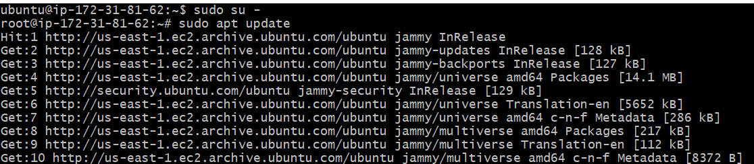

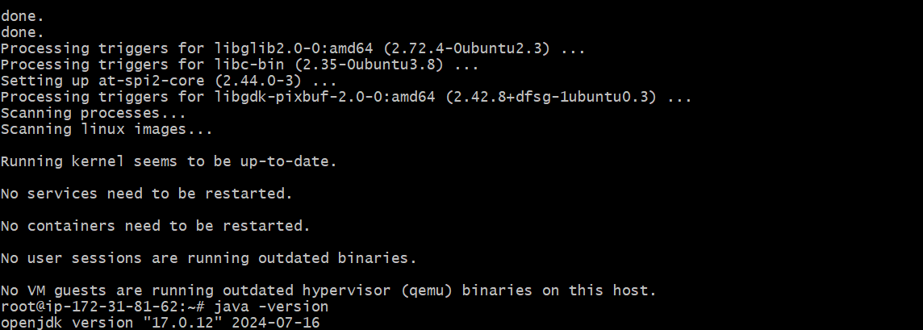

sudo wget -O /usr/share/keyrings/jenkins-keyring.asc \

https://pkg.jenkins.io/debian-stable/jenkins.io-2023.key

echo "deb [signed-by=/usr/share/keyrings/jenkins-keyring.asc]" \

https://pkg.jenkins.io/debian-stable binary/ | sudo tee \

/etc/apt/sources.list.d/jenkins.list > /dev/null

sudo apt-get update

sudo apt-get install Jenkins

sudo systemctl enable Jenkins

sudo systemctl start jenkins

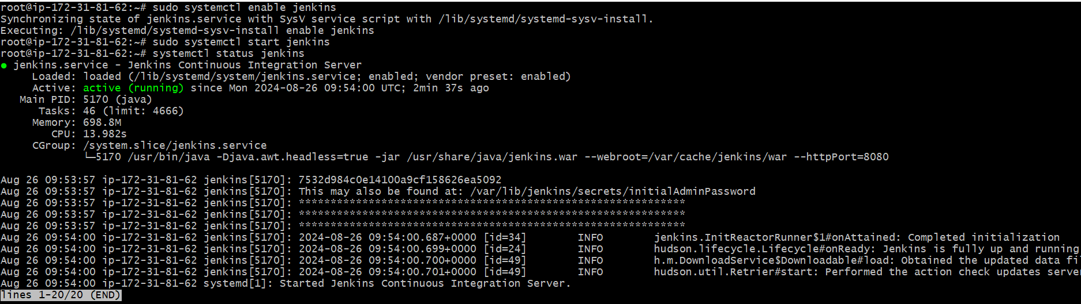



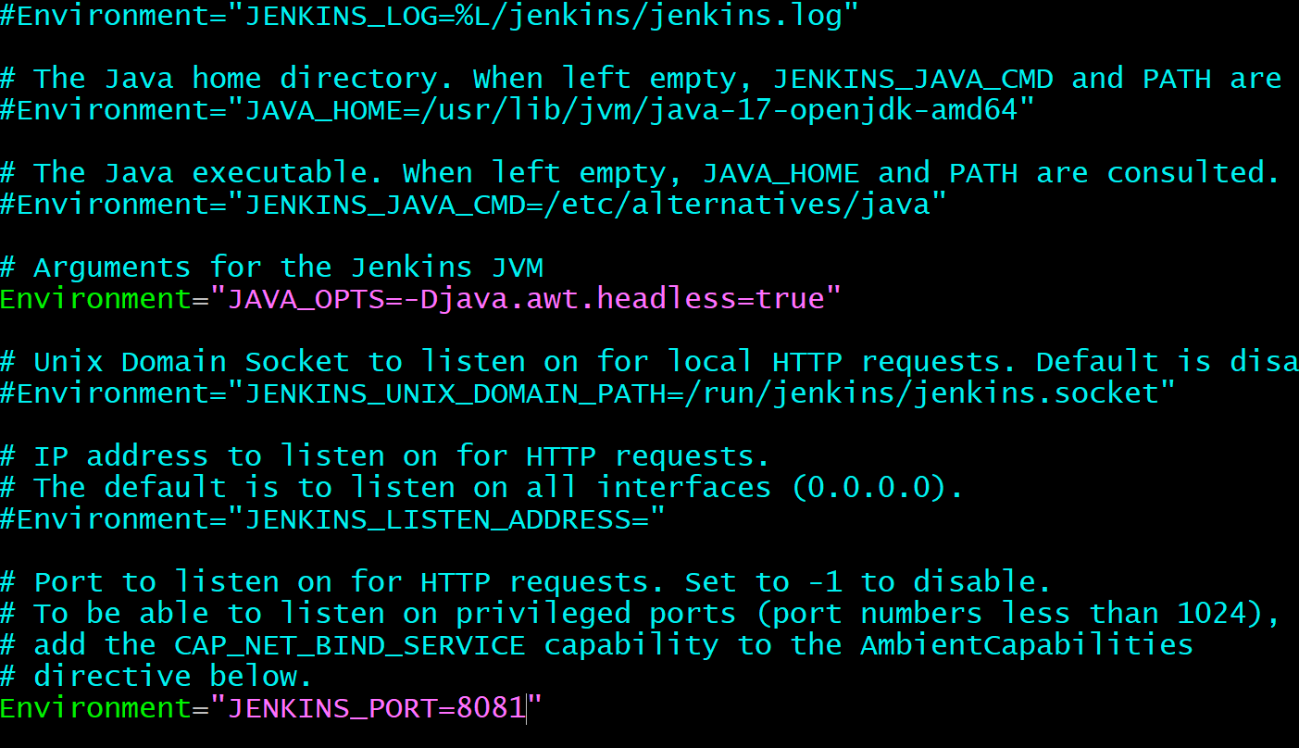

2) Secure Jenkins server

3) Create users called Devops, Testing in Jenkins with Limited access.

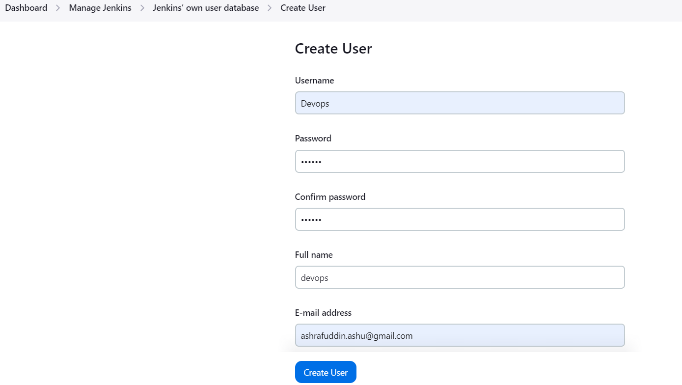

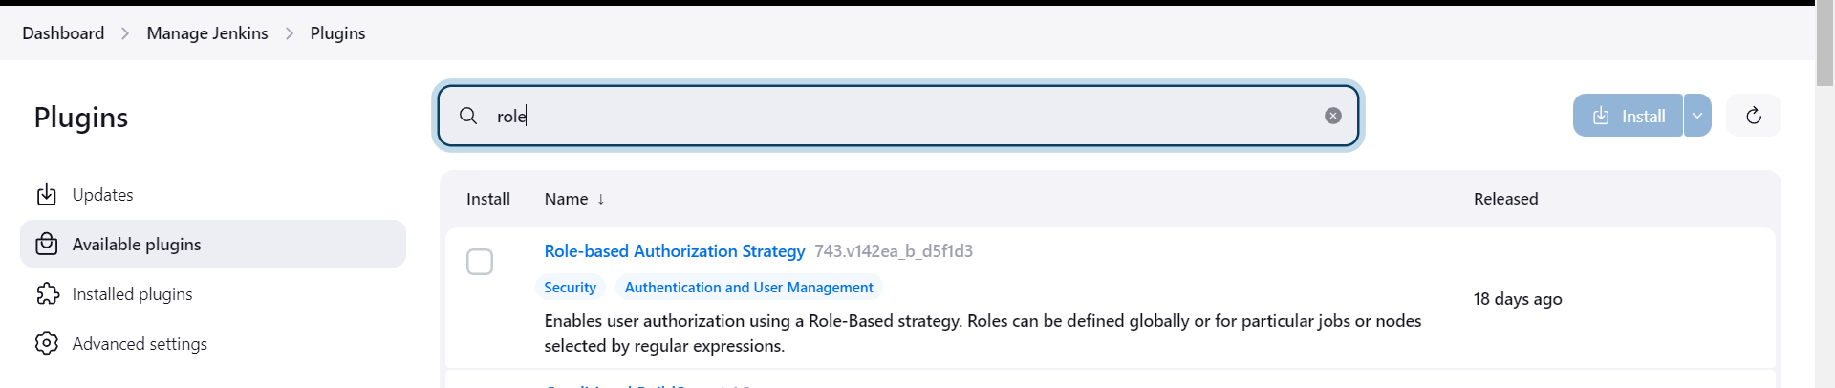

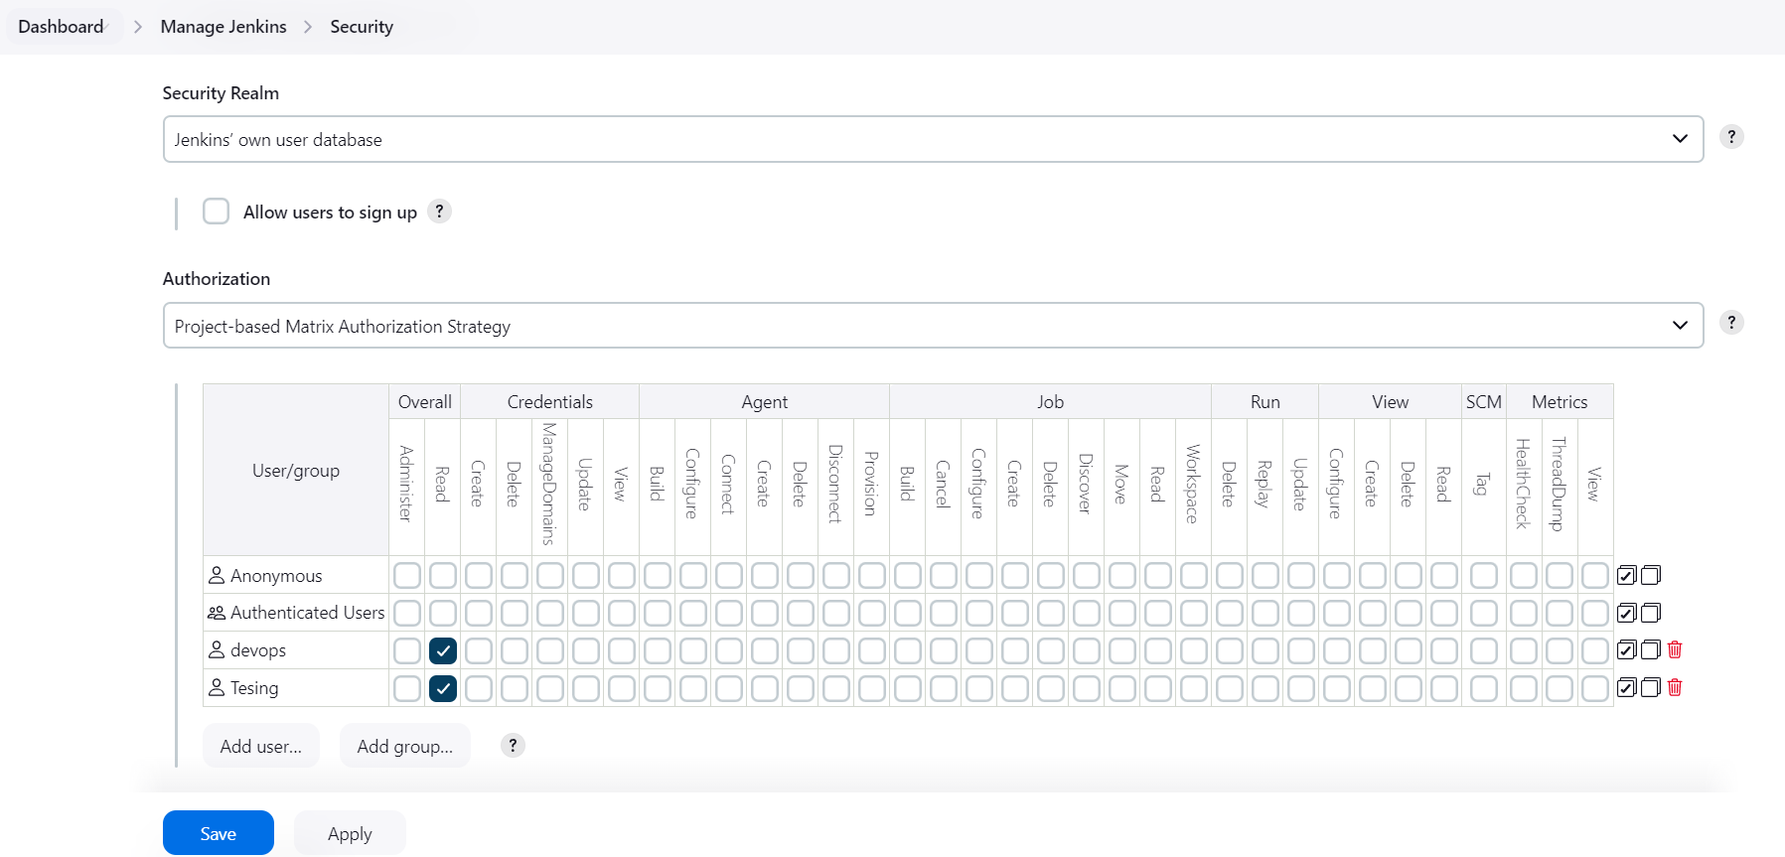

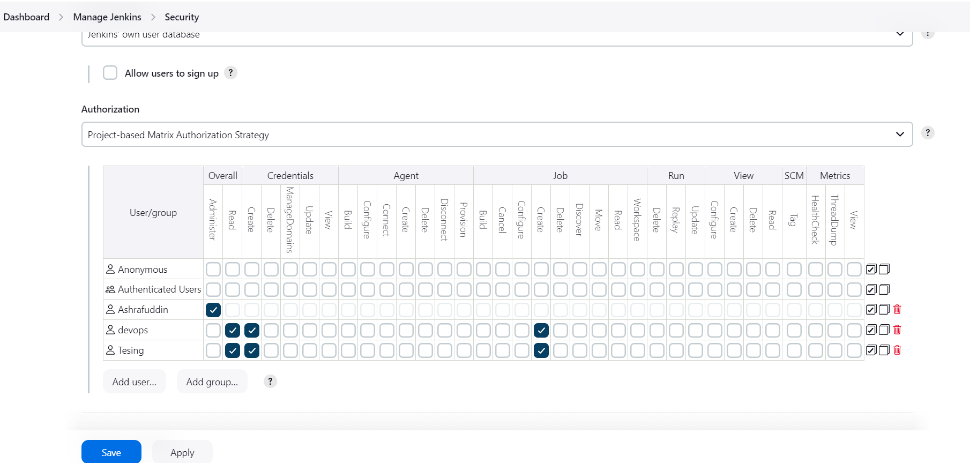

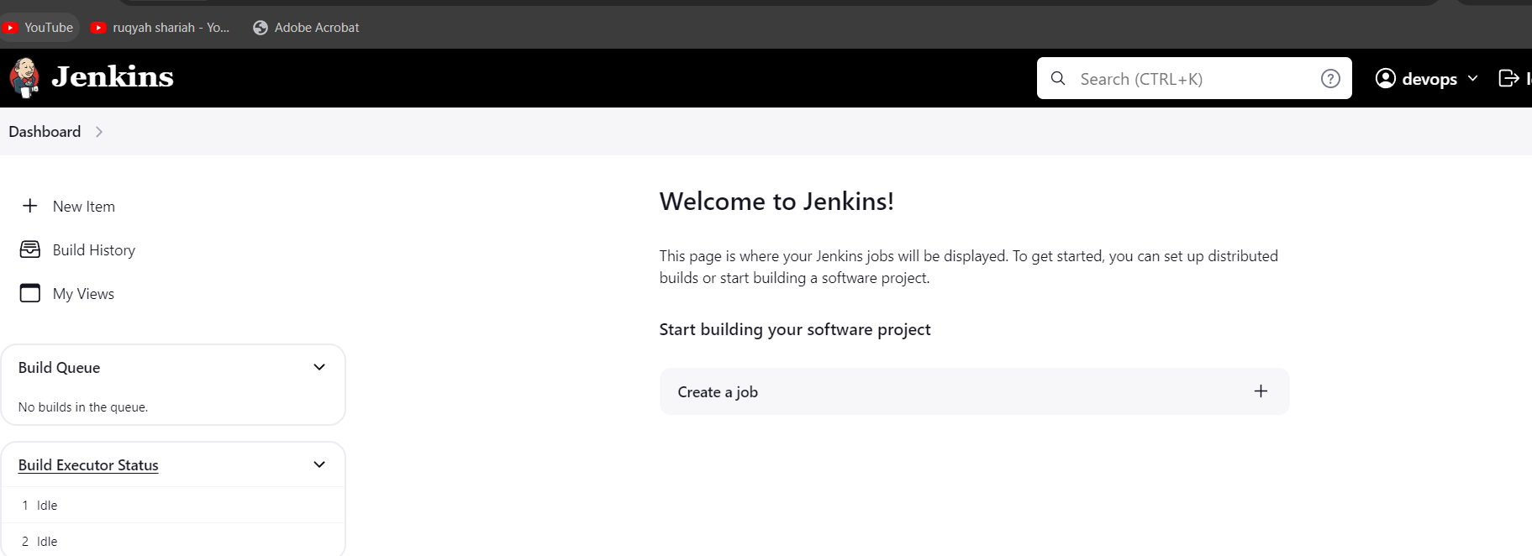

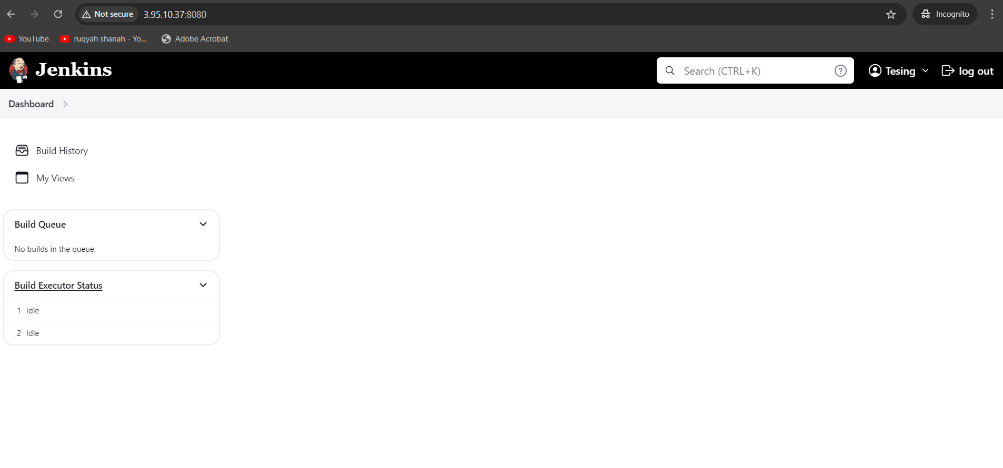

4) Configure labels and restrict the jobs to execute based on –

5) Create Three sample jobs using the below URL.

<https://github.com/betawins/Techie_horizon_Login_app.git>

6) Create one jenkins job using git hub Private repository.

* Create an access token in github
* Goto >account >Settings> Developer Settings> Personal Access Token> Tokens(Classic) – Enter general information and create one token and copy the token id.
* >Goto Jenkins and create credentials add username as github user name and paste access token in the password and enter any random id and save.
* Now you can save it and build.
* and added credentials in jenkins.

Now to git hub account setings

